**AIC HW3**

111511076 陳彥宇

**Problem 1:**

|  |  |  |  |
| --- | --- | --- | --- |
|  | Acm (V/V) | Adm (V/V) | CMRR (V/V) |
| (a) | 165.6810m | -13.4153 | 79.7635 |
| (b) | 37.1281m | -4.0028 | 107.8105 |

**Problem 1 code:**

1. ***-----------------------***

2. ***        setting        ***

3. ***-----------------------***

4. .lib "~/U18_HSPICE_Model/mm180_reg18_v124.lib" tt

5. .TEMP 25

6. .op

7. ***-----------------------***

8. ***       simulation      ***

9. ***-----------------------***

10. .option post

11. .tran 0.1n 30u

12. .probe I(M1_n)

13. .probe I(M2_n)

14. .probe Vout=V(x,y)

15. *.DC Vgs  0V 1.8V 0.05V sweep T 0 80 10

16.

17. ***-----------------------***

18. ***      parameters       ***

19. ***-----------------------***

20. .global VDD GND Vbs Vb

21.

22. ***-----------------------***

23. ***       measure         ***

24. ***-----------------------***

25. .meas tran Vx_max  max  v(x)   from=0.1ns to=30us

26. .meas tran Vx_min  min  v(x)   from=0.1ns to=30us

27. .meas tran Vx_Vpp  param ='Vx_max - Vx_min'

28.

29. .meas tran Vy_max  max  v(y)   from=0.1ns to=30us

30. .meas tran Vy_min  min  v(y)   from=0.1ns to=30us

31. .meas tran Vy_Vpp  param ='Vy_max - Vy_min'

32.

33. .meas tran Vin_max  max  v(V_diff+)   from=0.1ns to=30us

34. .meas tran Vin_min  min  v(V_diff+)   from=0.1ns to=30us

35. .meas tran Vin_Vpp  param ='Vin_max-Vin_min'

36.

37. .meas tran Vout_max  param ='Vx_max - Vy_min'

38. .meas tran Vout_min  param ='Vx_min - Vy_min'

39. .meas tran Vout_Vpp  param ='Vout_max - Vout_min'

40.

41. .meas tran Vdiff_max  max  v(Vdiff)   from=0.1ns to=30us

42. .meas tran Vdiff_min  min  v(Vdiff)   from=0.1ns to=30us

43. .meas tran Vdiff_Vpp  param ='Vdiff_max - Vdiff_min'

44.

45. .meas tran Adm  param ='-Vout_Vpp / Vdiff_Vpp'

46. *.meas tran Acm  param ='-Vx_Vpp / Vin_Vpp'

47. *.meas tran CMRR  param ='Adm / Acm'

48.

49. *MAX tells Hspice to take the max value of V/I of variable during t1 ~ t2

50. ***-----------------------***

51. ***      power/input      ***

52. ***-----------------------***

53. Vsupply VDD GND 3v

54. *              SIN(Offset   Amplitude   Freq.   Delay )

55. V1      Vbs GND 0.6v

56. V2      Vb  GND 2v

57. Vcm     N0  GND 1v

58. V4      Vdiff  GND SIN(0   1m   100k  0)

59. EV+     V_diff+ N0 Vdiff GND +0.5

60. EV-     V_diff- N0 Vdiff GND -0.5

61. ***-----------------------***

62. ***        circuit        ***

63. ***-----------------------***

64. R1  VDD  X   5k

65. R2  VDD  Y   5k

66. M1_n  X  V_diff+    Virtual       GND    n_18_mm w=45u l=0.3u

67. M2_n  Y  V_diff-    Virtual       GND    n_18_mm w=45u l=0.3u

68. M5_n  Virtual  Vbs        GND     GND    n_18_mm w=75u l=1u

69.

70. .subckt CKT_A   Vin_pos Vin_neg  X   Y

71. R1  VDD  X   5k

72. R2  VDD  Y   5k

73. M1_n  X  Vin_pos    V       GND    n_18_mm w=45u l=0.3u

74. M2_n  Y  Vin_neg    V       GND    n_18_mm w=45u l=0.3u

75. M5_n  V  Vbs        GND     GND    n_18_mm w=75u l=1u

76. .ends

77.

78. .subckt CKT_B   Vin_pos Vin_neg  X   Y

79. M3_p  X  X          VDD     VDD    p_18_mm w=10u l=0.3u

80. M4_p  Y  Y          VDD     VDD    p_18_mm w=10u l=0.3u

81. M1_n  X  Vin_pos    V       GND    n_18_mm w=45u l=0.3u

82. M2_n  Y  Vin_neg    V       GND    n_18_mm w=45u l=0.3u

83. M5_n  V  Vbs        GND     GND    n_18_mm w=75u l=1u

84. .ends

85.

86. .subckt CKT_C   Vin_pos Vin_neg  X   Y

87. M3_p  X  Vb         VDD     VDD    p_18_mm w=10u l=0.3u

88. M4_p  Y  Vb         VDD     VDD    p_18_mm w=10u l=0.3u

89. M1_n  X  Vin_pos    V       GND    n_18_mm w=45u l=0.3u

90. M2_n  Y  Vin_neg    V       GND    n_18_mm w=45u l=0.3u

91. M5_n  V  Vbs        GND     GND    n_18_mm w=75u l=1u

92. .ends

93.

94. .end

**Problem 2:**

**Derivation of Max Input Amplitude & Output Swing:**

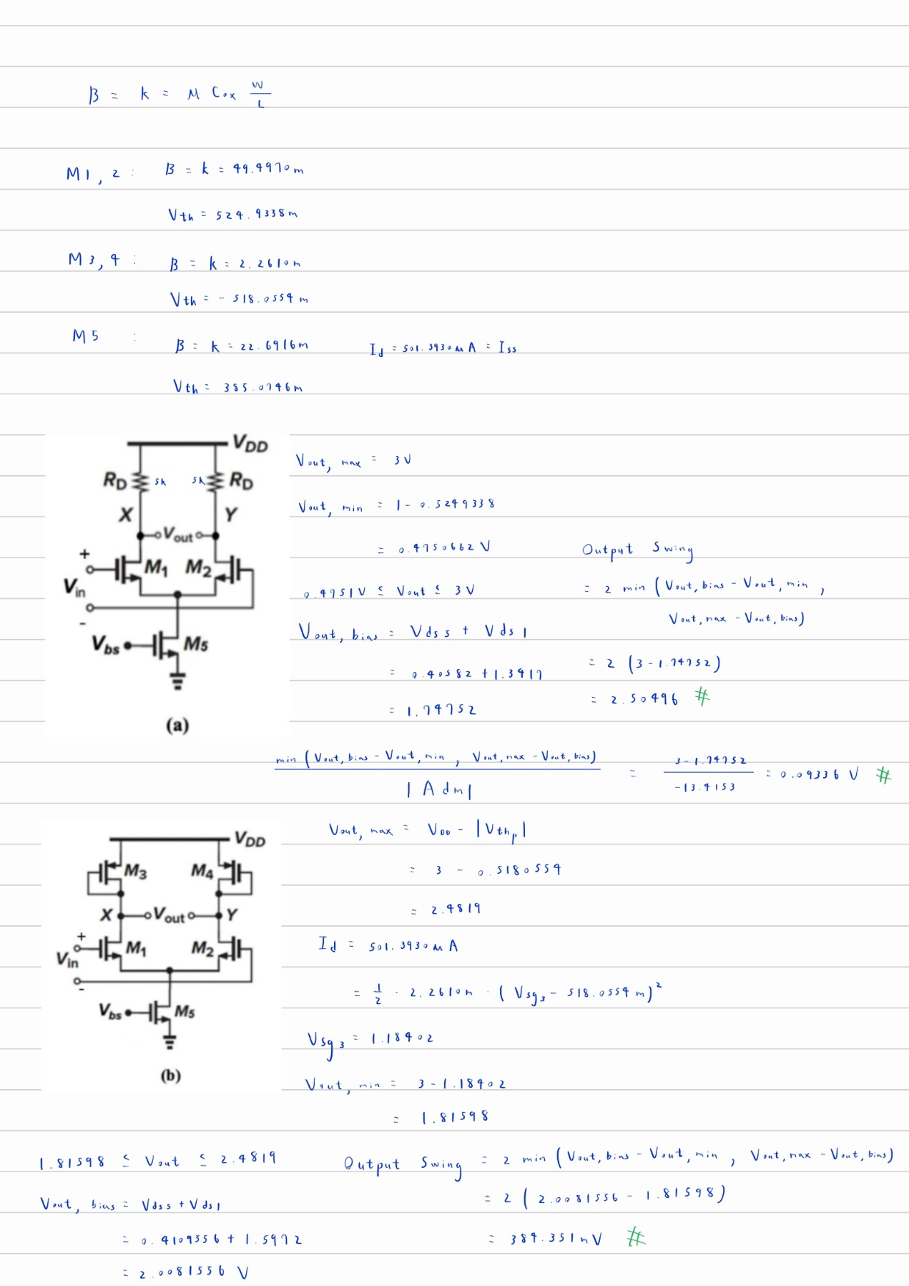

|  |  |  |  |  |  |  |
| --- | --- | --- | --- | --- | --- | --- |
|  | DC Gain (V/V) | Vout, bias (V) | Vout, min (V) | Vout, max (V) | Output Swing (V) | Max Input Signal Amplitude (V) |
| (a) | -13.4151 | 1.748 | 0.475 | 3 | 2.505 | 93.36m |
| (b) | -4.0028 | 2.008 | 1.816 | 2.482 | 384.351m | 48.01m |
| (c) | -30.7332 | 2.208 | 0.475 | 2.334 | 252.761m | 4.112m |

The circuits (a), (b), (c) are identical to 2.2 of handwrite handwork 2. We can use the same calculation methods employed in the handwrite homework to acquire the Vout, max & Vout, min.

The maximum output swing is defined as the difference between the maximum and minimum output voltages. This is limited by the bias voltage Vout, bias caused by setting Vicm to 1V. The output swing is given by the following equation:

$$Output Swing=2min(V_{out,max}-V_{out,bias}, V_{out,bias}-V_{out,min})$$

Next, to determine the max amplitude of the input signal, I use the following equation:

$\frac{min(V_{out,max}-V_{out,bias}, V_{out,bias}-V_{out,min})}{|A_{dm}|}$ = *Max Input Amplitude*

This helps us find a suitable input that satisfies the requirement of the problem and keeps all transistors in saturation.

**Circuit (a) Waveform & MOSFET Operating Region:**

**Circuit (b) Waveform & MOSFET Operating Region:**

**Circuit (c) Waveform & MOSFET Operating Region:**

**Code for Problem 2 & 3:**

1. ***-----------------------***

2. ***        setting        ***

3. ***-----------------------***

4. .lib "~/U18_HSPICE_Model/mm180_reg18_v124.lib" tt

5. .TEMP 25

6. .op

7. ***-----------------------***

8. ***       simulation      ***

9. ***-----------------------***

10. .option post

11. .tran 0.1n 30u

12. .probe I(M1_n)

13. .probe I(M2_n)

14. .probe Vout=V(x,y)

15. *.DC Vgs  0V 1.8V 0.05V sweep T 0 80 10

16.

17. ***-----------------------***

18. ***      parameters       ***

19. ***-----------------------***

20. .global VDD GND Vbs Vb

21. ***-----------------------***

22. ***      power/input      ***

23. ***-----------------------***

24. Vsupply VDD GND 3v

25. *              SIN(Offset   Amplitude   Freq.   Delay )

26. V1      Vbs GND 0.6v

27. V2      Vb  GND 2v

28. Vcm     N0  GND 1v

29. V4      Vdiff  GND SIN(0   1m   100k  0)

30. EV+     V_diff+ N0 Vdiff GND +0.5

31. EV-     V_diff- N0 Vdiff GND -0.5

32. ***-----------------------***

33. ***        circuit        ***

34. ***-----------------------***

35. R1  VDD  X   5k

36. R2  VDD  Y   5k

37. M1_n  X  V_diff+    Virtual       GND    n_18_mm w=45u l=0.3u

38. M2_n  Y  V_diff-    Virtual       GND    n_18_mm w=45u l=0.3u

39. M5_n  Virtual  Vbs        GND     GND    n_18_mm w=75u l=1u

40.

41. .subckt CKT_A   Vin_pos Vin_neg  X   Y

42. R1  VDD  X   5k

43. R2  VDD  Y   5k

44. M1_n  X  Vin_pos    V       GND    n_18_mm w=45u l=0.3u

45. M2_n  Y  Vin_neg    V       GND    n_18_mm w=45u l=0.3u

46. M5_n  V  Vbs        GND     GND    n_18_mm w=75u l=1u

47. .ends

48.

49. .subckt CKT_B   Vin_pos Vin_neg  X   Y

50. M3_p  X  X          VDD     VDD    p_18_mm w=10u l=0.3u

51. M4_p  Y  Y          VDD     VDD    p_18_mm w=10u l=0.3u

52. M1_n  X  Vin_pos    V       GND    n_18_mm w=45u l=0.3u

53. M2_n  Y  Vin_neg    V       GND    n_18_mm w=45u l=0.3u

54. M5_n  V  Vbs        GND     GND    n_18_mm w=75u l=1u

55. .ends

56.

57. .subckt CKT_C   Vin_pos Vin_neg  X   Y

58. M3_p  X  Vb         VDD     VDD    p_18_mm w=10u l=0.3u

59. M4_p  Y  Vb         VDD     VDD    p_18_mm w=10u l=0.3u

60. M1_n  X  Vin_pos    V       GND    n_18_mm w=45u l=0.3u

61. M2_n  Y  Vin_neg    V       GND    n_18_mm w=45u l=0.3u

62. M5_n  V  Vbs        GND     GND    n_18_mm w=75u l=1u

63. .ends

64.

65. .end

**Problem 3:**

|  |  |  |  |
| --- | --- | --- | --- |
|  | DC Gain (V/V) | Rout (Ω) | Output Swing(V) |
| (b) | -4.0028 | 2.0583k | 1.33184 |
| (c) | -30.7332 | 15.7615k | 3.71792 |

(b) is a differential amplifier biased using diode-connected transistors M3 & M4, while (c) is biased using PMOS current sources. The diode-connected transistors provide a **fixed voltage drop** and are easier to implement, but they don't provide optimal performance in terms of output swing or gain. he diode connection reduces the voltage swing at the output because part of the supply voltage is consumed by the voltage drop across M3​ and M4​. The current-source biasing provides **higher output swing** and **better gain** compared to diode-connected biasing. It also allows more flexibility in controlling the current flowing through the differential pair by adjusting Vb.

|  |  |  |
| --- | --- | --- |
|  | Diode-Connected | Current Source |
| Pros | Simple to Implement | Higher Gain, Larger Output Swing |
| Cons | Sacrifices Gain, Output Swing & Input CM Range | More Complex to Implement |